Assignment – 4

**By: Atharva Sachin Tilak**

I]

i) tellg():

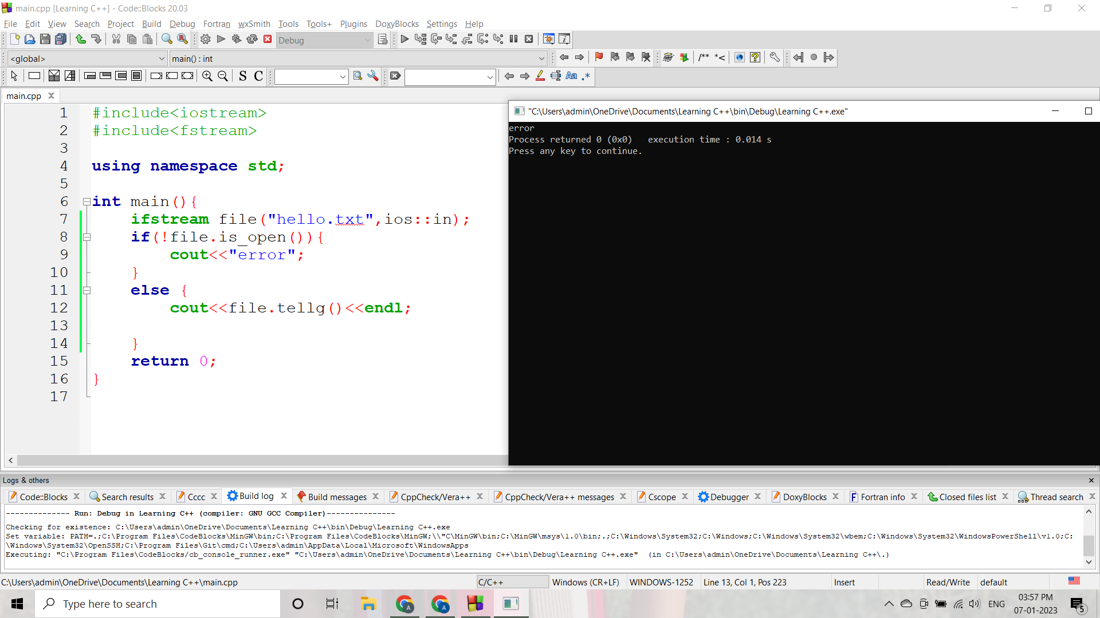

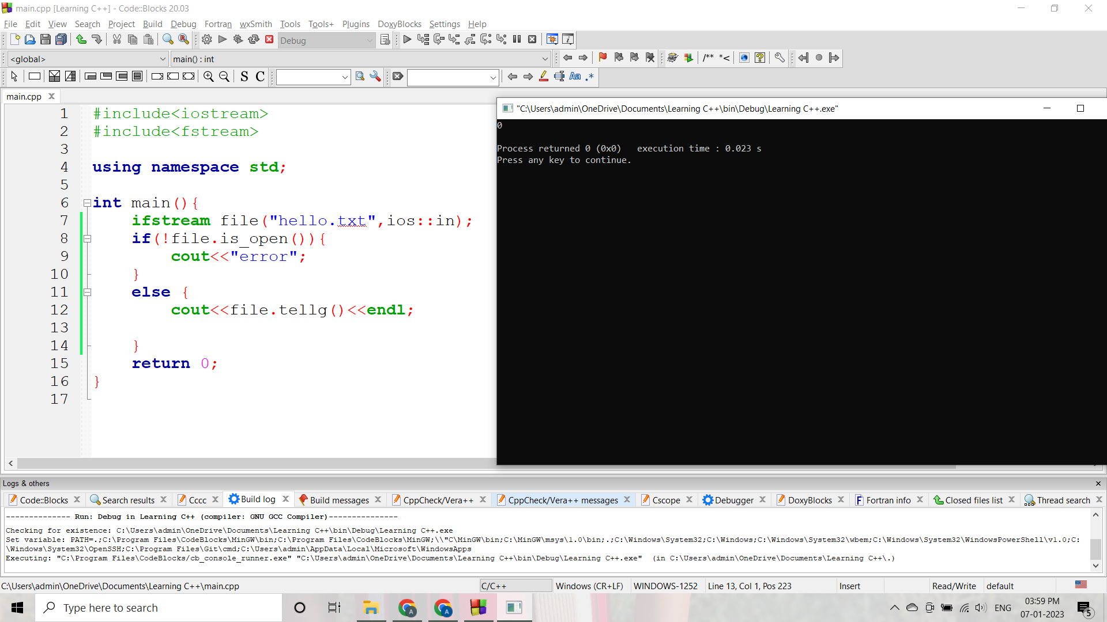

ii) tellp()

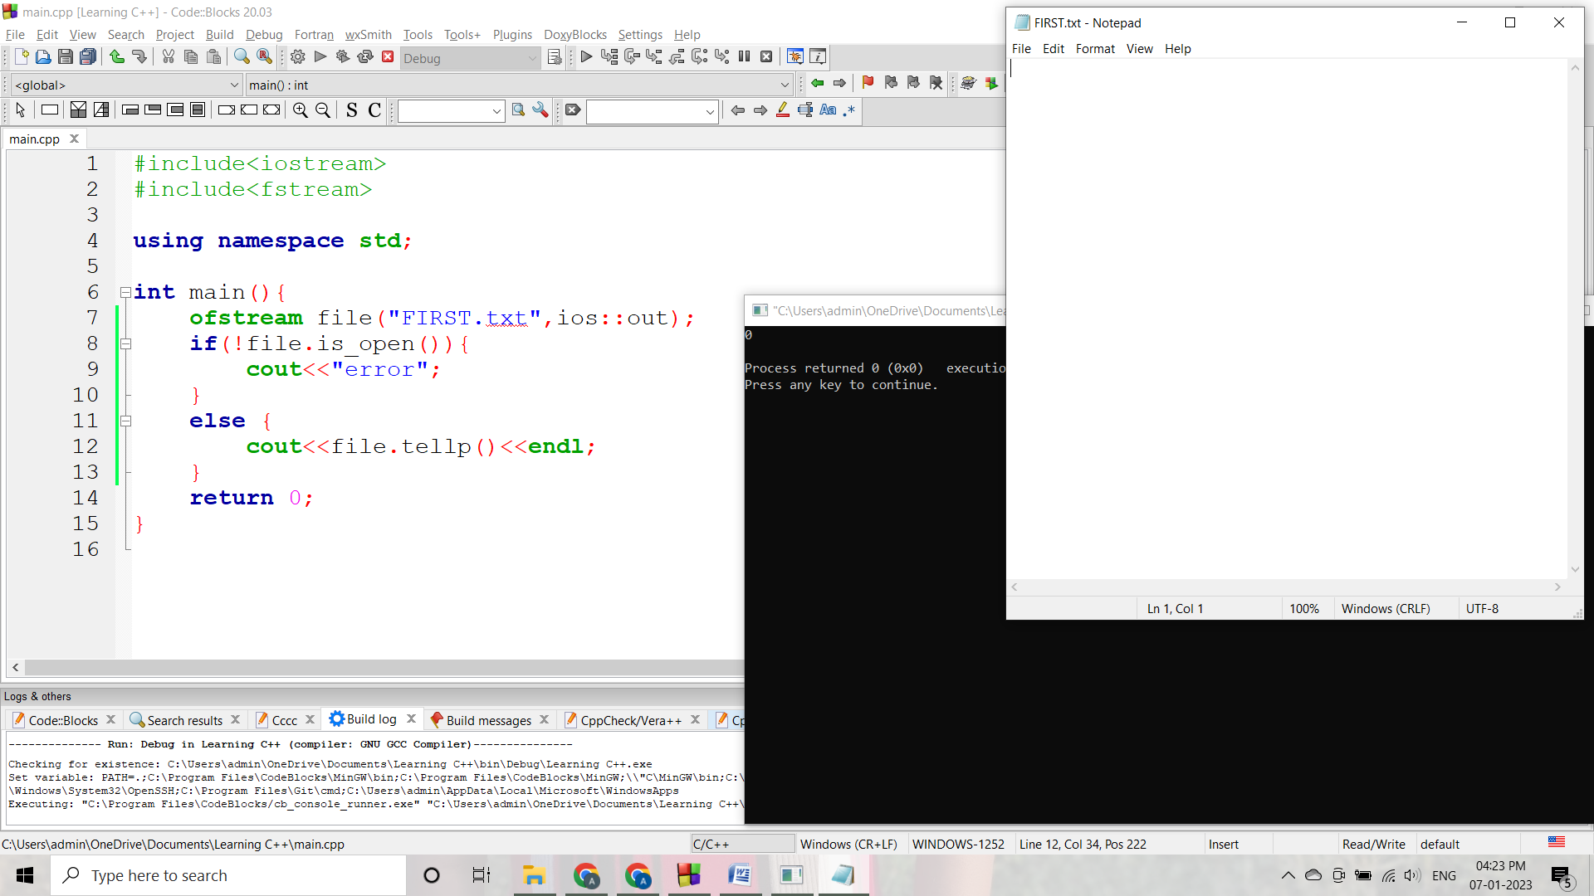

iii) seekg():

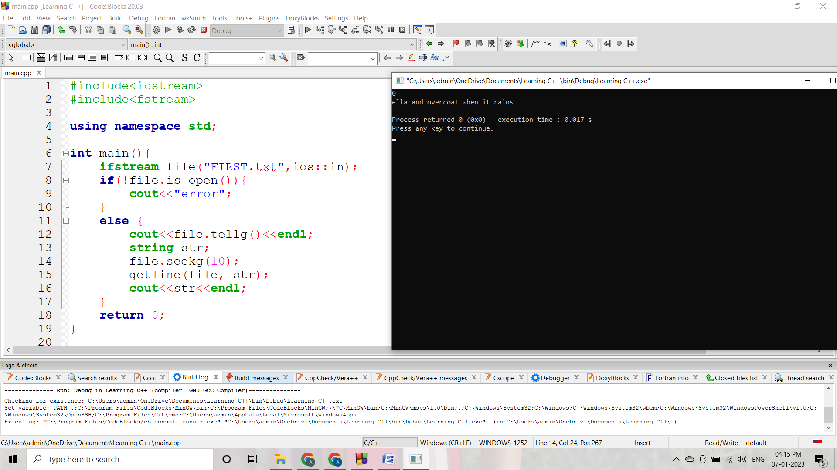

iv) seekp():

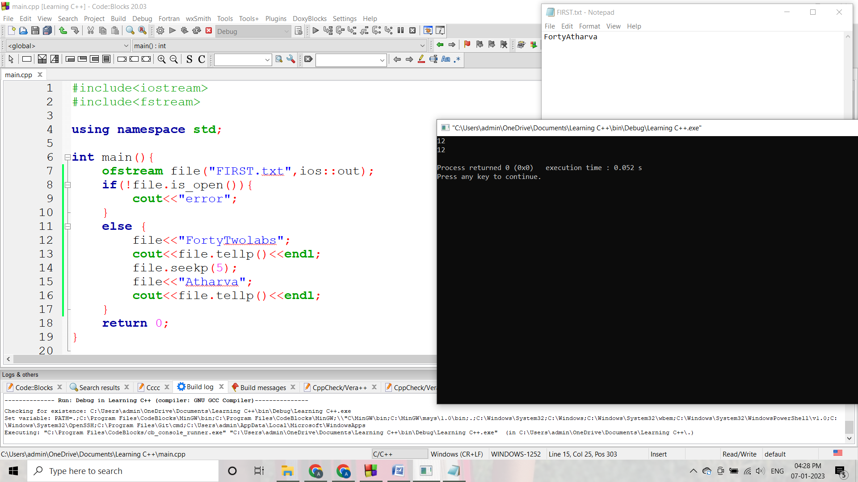

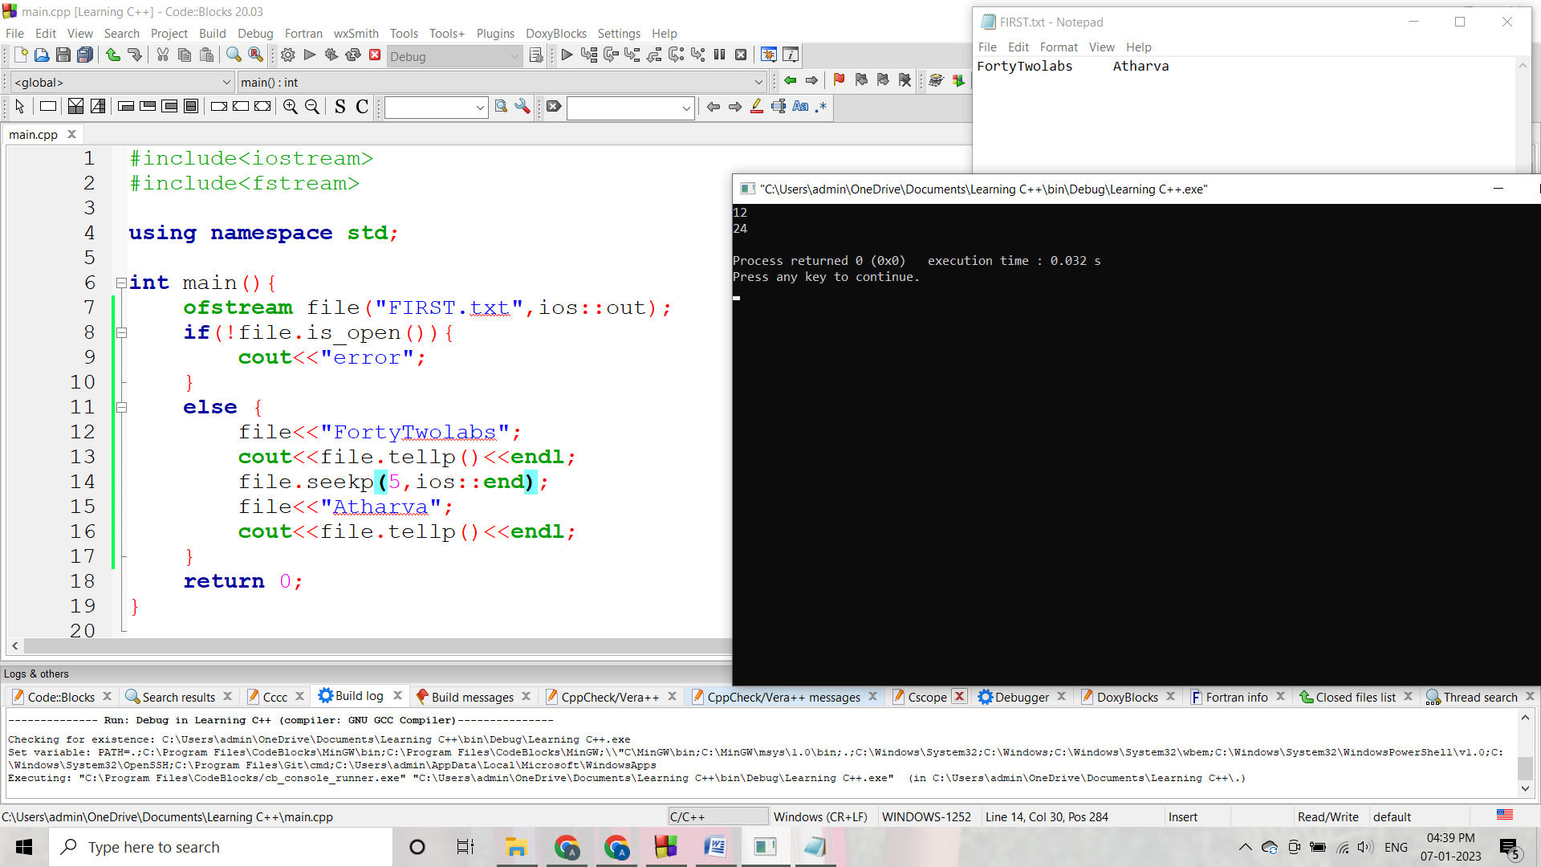

v) get() && put():

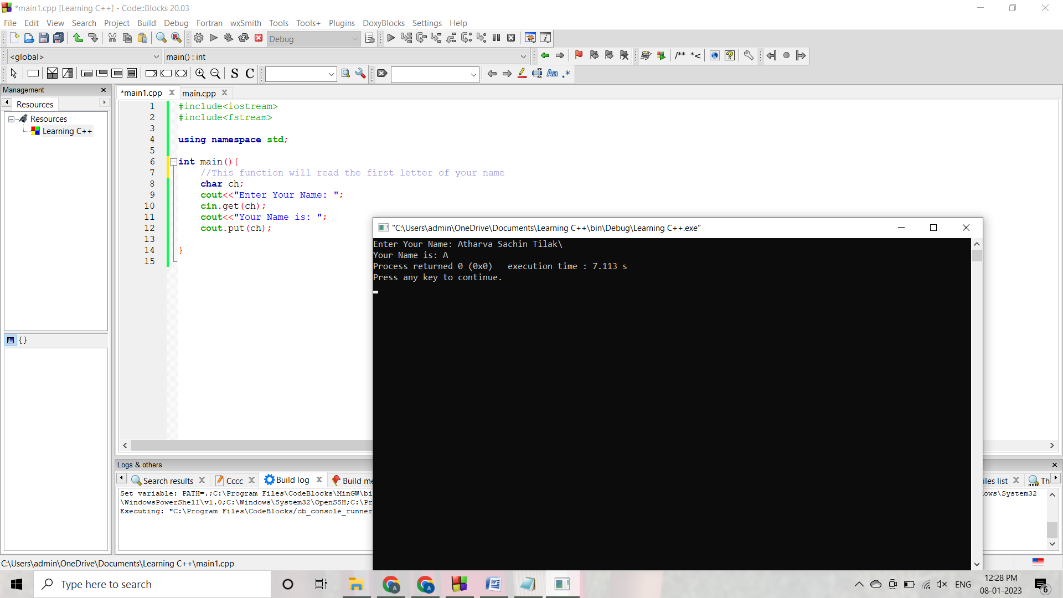

II]

Code:

#include<iostream>

#include<fstream>

using namespace std;

void vowelwords(){

string result, word;

ifstream first("FIRST.txt",ios::in);

ofstream second("SEOCND.txt",ios::out);

if(!first.is_open()){

result = "error";

}

else {

getline(first, result);

}

for(int i=0; i<result.size(); i++){

char x=result.at(i);

if(x==' '){

if(word.at(0)=='a' || word.at(0)=='e' || word.at(0)=='i' || word.at(0)=='o' || word.at(0)=='u'){

second<<word<<' ';

}

word.clear();

}

else {

word = word+x;

}

}

}

int main(){

vowelwords();

return 0;

}

Output:

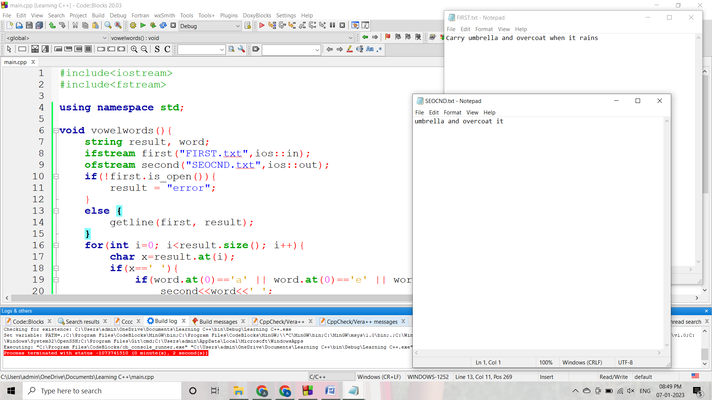

III]

Code:

#include<iostream>

#include<fstream>

using namespace std;

void words(){

int l=0, upper=0, lower=0, spaces=0;

string result;

ifstream story("STORY.txt",ios::in);

while(getline(story, result)){

for(int i=0; i<result.length(); i++){

if(result[i]>='A' && result[i]<='Z'){

upper++;

}

else if(result[i]>='a' && result[i]<='z'){

lower++;

}

else if(result[i]==' '){

spaces++;

}

}

if(result.at(0)=='T'){

cout<<result<<"\n";

}

l++;

}

cout<<"Number of lines: "<<l<<endl;

cout<<"Number of spaces: "<<spaces<<endl;

cout<<"Number of uppercase letters: "<<upper<<endl;

cout<<"Number of lowercase letters: "<<lower;

}

int main(){

words();

return 0;

}

Output:

